Task 12.1: E-Commerce - Sales Performance Dashboard

Overview:
The Sales Performance Dashboard provides a comprehensive analysis of sales performance across products, regions, channels, and customer behavior. The objective of this dashboard is to help management monitor revenue trends, customer satisfaction, return rate, and overall business growth from 2021 to 2024.
This dashboard enables data-driven decision-making by tracking key financial and operational KPIs in a single view.

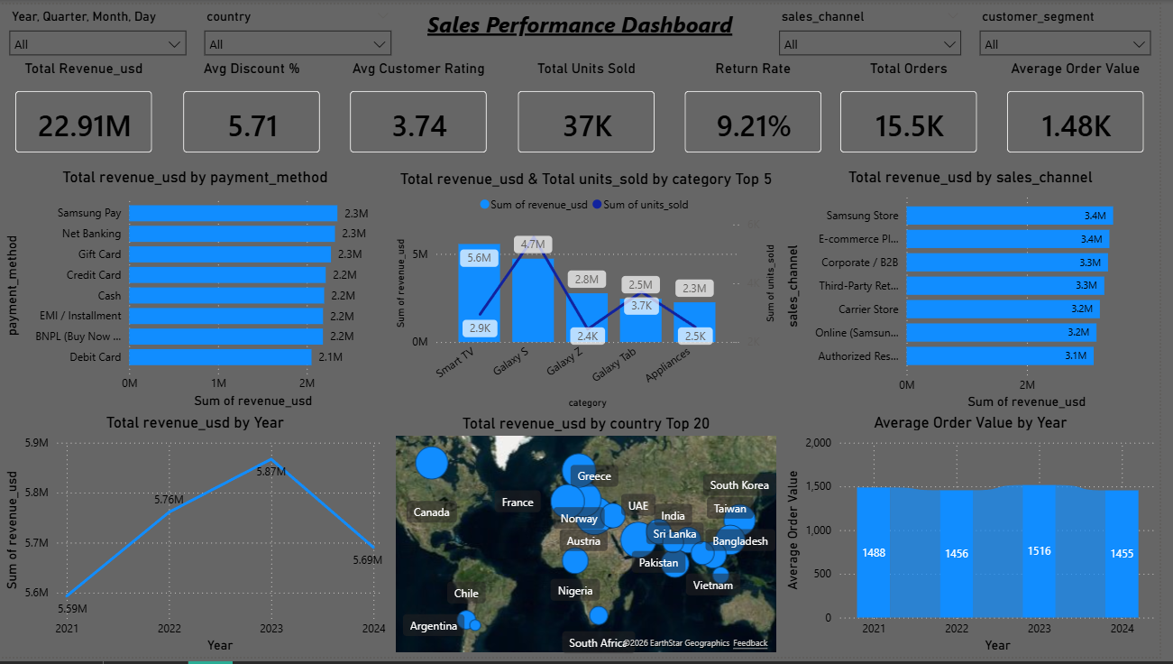
Data Scope:
The dataset includes:
- Sales transactions
- Product details
- Regional information
- Customer segmentation
- Payment methods
- Discount information
- Return status
- Customer ratings
Time Period Covered: 2021 – 2024

Key Performance Indicators (KPI Summary):
- How much total revenue have we generated?
  - Total Revenue: $22.91M
The company generated a total revenue of 22.91 million USD during the selected
time period

- How many total sales transactions were completed?
  - Total Orders: 15.5K
The company processed 15,500 sales transactions.

- How many total units have we sold?
  - Total Units Sold: 37K units
A total of 37,000 units were sold across all categories.
- On average, how much revenue does each order generate?
  - Average Order Value: $1.48K
Each order generates approximately $1,480 in revenue on average. This
indicates a strong premium pricing strategy.
- What is the average discount given per order?
  - Average Discount %: 5.71%
On average, customers received a 5.71% discount per transaction. This indicates
moderate promotional activity without heavy margin impact.

- What percentage of orders were returned?
  - Return Rate: 9.21%
Approximately 9% of orders were returned. This is slightly high and may require
investigation into product quality or customer expectations.
- What is the average customer satisfaction score?
  - Average Customer Rating: 3.74/5
Customer satisfaction is moderately positive but leaves room for improvement.

Charts:
Revenue distribution across payment methods shows: (Stack bar chart)
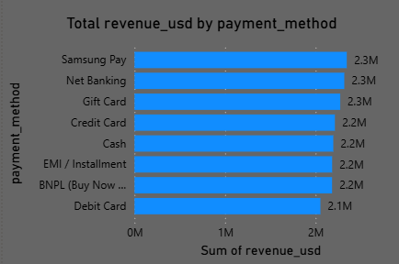
- Samsung Pay – $2.3M
- Net Banking – $2.3M
- Gift Card – $2.3M
- Credit Card – $2.2M
- Cash – $2.2M
- EMI / Installment – $2.2M
- BNPL (Buy Now Pay Later) – $2.2M
- Debit Card – $2.1M

Insight:
Revenue contribution is well-balanced across payment methods, showing customers prefer multiple payment options. No heavy dependency on a single payment channel.

Revenue & Units Sold by Category: (Line & Stacked Column chart Top 5)
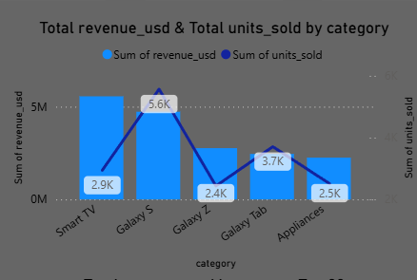

Observations:
- Smart TV generate the highest revenue (~5.6M).
- Galaxy S generates revenue (~4.7M).
- Galaxy Z and Galaxy Tab show moderate performance (~2.8M to ~ 2.5M).
- Appliances generate relatively lower revenue (~2.3M).
Units sold are aligned with revenue trends, indicating consistent pricing structure.

Revenue by Sales Channel: (Stacked Bar chart)
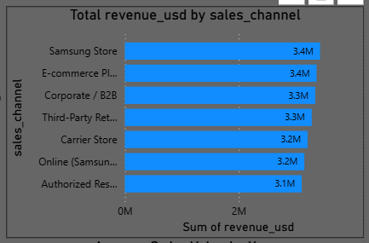
Top performing channels:
- Samsung Store – $3.4M
- E-commerce Platform – $3.4M
- Corporate / B2B – $3.3M
- Third-Party Retailers – $3.3M
- Carrier Store – $3.2M
- Online (Samsung Website) – $3.2M
- Authorized Resellers – $3.1M

Insight:
Revenue distribution across channels is balanced. Both offline retail and online platforms contribute almost equally. This indicates strong omnichannel performance.

Revenue Trend by Year (2021-2021): (Line Chart)
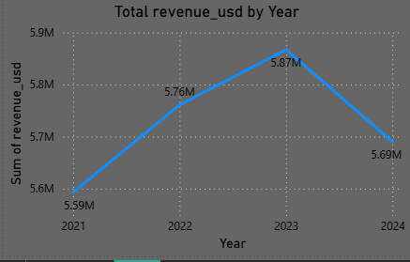
- 2021: $5.59M
- 2022: $5.76M
- 2023: $5.87M (Peak Year)
- 2024: $5.69M (Slight Decline)

Insight:
Revenue showed steady growth from 2021 to 2023. However, a slight dip occurred in 2024, which may indicate:
- Increased competition
- Reduced demand
- Pricing changes
- Economic slowdown

Revenue by Country (Top 20): (Map chart)
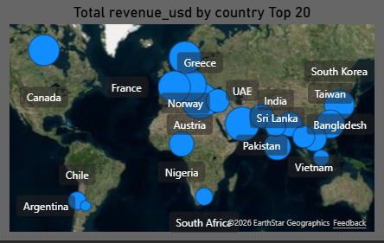
The map visualization shows global revenue distribution by size.
Key revenue-generating regions include:
- North America
- Europe
- South Asia
- Middle East
Countries like Canada, France, Greece, UAE, India, Sri Lanka, Bangladesh, South Korea, and Taiwan contribute significantly.

Insight:
The company has strong international market penetration. Growth opportunities exist in underperforming regions.

Average Order Value by Year: (Ribbon chart)
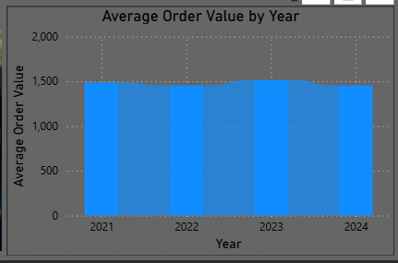
- 2021: 1488
- 2022: 1456
- 2023: 1516
- 2024: 1455
Average order value remains relatively stable between 1450 - 1500 from 2021 to 2024
Insight:
Stable Average order value indicates:
- Consistent pricing strategy
- Stable product positioning
- No aggressive discounting strategy

Slicers Used:
To improve interactivity, the following slicers were implemented:
- Year, Quarterly, Day – For annual, quarterly & comparison
- Country – For geographic filtering
- Sales Channel – For channel comparison
- Customer Segment – For customer-based insights
These slicers allow dynamic filtering of all visuals.

Business Insights & Recommendations
Strengths
- Strong multi-channel revenue distribution
- Stable Average order value
- Consistent revenue growth until 2023
- Balanced payment ecosystem
Areas of Improvement
- 9.21% return rate should be reduced
- 2024 revenue dip needs investigation
- Customer rating (3.74) can be improved
Recommendations
- Improve product quality control to reduce returns
- Launch customer satisfaction initiatives
- Focus marketing efforts in high-performance regions
- Promote high-revenue categories like Galaxy S and Smart TV
- Investigate reasons behind 2024 revenue decline.
Learnings:
- Values of DAX measure and direct drag & drop varies. Data format changes are required for proper insight of data value.

